Lecturer’s name: N/A | Date: Day 10
Course: Math | Unit: Equivalent Forms of Fractions, Decimals, and Percents
Unit Duration: 10 days | Lesson Duration: 1 day
TEKS: All TEKS covered in this unit  6.4 E, 6.4 F, 6.4 G, 6.5 B, 6.5 C, 6.1 A, 6.1 B, 6.1 C, 6.1 D,  6.1.A apply mathematics to problems arising in everyday life, society, and the workplace;  6.1.B use a problem-solving model that incorporates analyzing given information, formulating a plan or strategy, determining a solution, justifying the solution, and evaluating the problem-solving process and the reasonableness of the solution;  6.1.C select tools, including real objects, manipulatives, paper and pencil, and technology as appropriate, and techniques, including mental math, estimation, and number sense as appropriate, to solve problems;  6.1.D communicate mathematical ideas, reasoning, and their implications using multiple representations, including symbols, diagrams, graphs, and language as appropriate;  6.4.E represent ratios and percent’s with concrete models, fractions, and decimals;  6.4.F represent benchmark fractions and percent’s such as 1%, 10%, 25%, 33 1/3%, and multiples of these values using 10 by 10 grids, strip diagrams, number lines, and numbers;  6.5.B solve real-world problems to find the whole given a part and the percent, to find the part given the whole and the percent, and to find the percent given the part and the whole, including the use of concrete and pictorial models; and  6.5.C use equivalent fractions, decimals, and percent’s to show equal parts of the same whole. | Lesson Part 1
Topic: Percents, Fractions and Decimals + Real World Problems

Lesson objectives:
- SWBAT apply all the knowledge learned in this unit onto the unit exam in TWO parts, Multiple Choice and Free Response

Essential Questions:
N/A

LYS Methodology

Be (Character/Values/Principles) - Educational, Financial, Vocational, Spiritual, Cultural - How can I use the strategies in a percent proportion to figure out how to manage my money and time better and understand how the world works around me in regards to value (consumer value)?

Know (What resources are available to the student/ How can they use them) - Educational and Financial - What kind of skills can using percentage help me learn more about material and service value?

Do (Execute with Excellence) - Educational, Financial, Spiritual and Social - How do these strategies help me be an independent young adult in the world?

Resources (Include Technology):
Independent Practice

Part 1: Multiple Choice Exam

Partt 2: Free Response ON PAPER

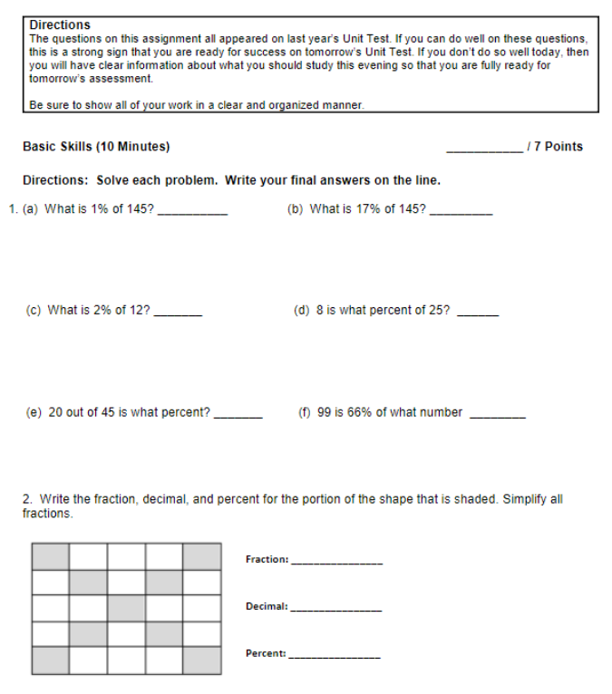

Lesson Close

Spiritual
“Financial literacy is important in life just as every other basics ” - Unknown

Knowing about percentages is important because we use this in our daily lives. We use percentages when we look at our battery life on our phones, when we are trying to use a specific service, when we are looking at pie charts, especially when we are looking at sales and sale taxes at stores. Learning to use these percentages will help students become successful in life. It is not just about learning to change decimals to percentages or fractions to percentages it is about learning to use these in the real world.

